**Enhancing Strategic Decision Making at Faith Global Analysis Report**

1. **Growth Rate Analysis:**
   1. What is the overall growth rate of attendance for Faith Global over the past year?

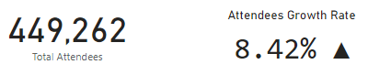

Generally, there have been a positive growth of 8.42% in the past year

* 1. Can you identify branches with the highest and lowest growth rates in attendance?

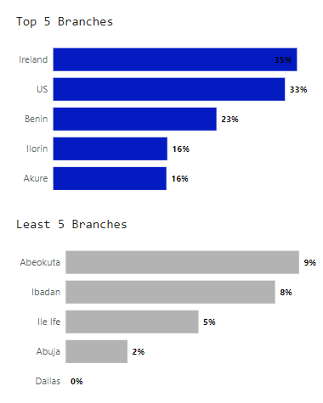

* 1. Are there any seasonal trends in attendance numbers? How do they impact overall growth?

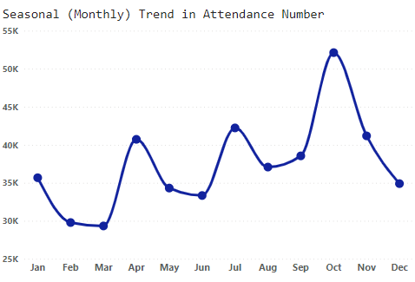

There is always high spike in number of attendants at the first month of every quatre, this can be as a result of personal resolution to be more active in church activities or probably any global programs fixed in these months.

1. **Gender Analysis:**

a. How does attendance vary between male and female attendees across all branches?

b. Is there a significant difference in attendance between genders? If so, what factors might contribute to this difference?

c. Are there any branches where one gender significantly outnumbers the other? If yes, what could be the underlying reasons?

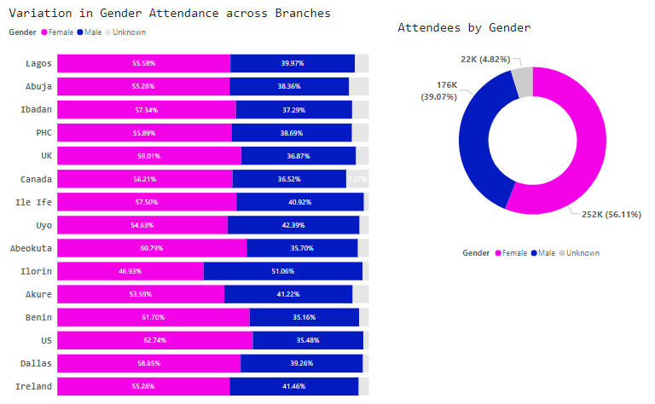

* 1. Majority of the branches have more female participants compared to their male counterparts

1. **Age Group Analysis:**

a. What is the attendance distribution among different age groups (e.g., kids, teenagers, adults) across branches?

b. Are there specific age groups that show higher attendance rates? If yes, what strategies can be implemented to further engage these age groups?

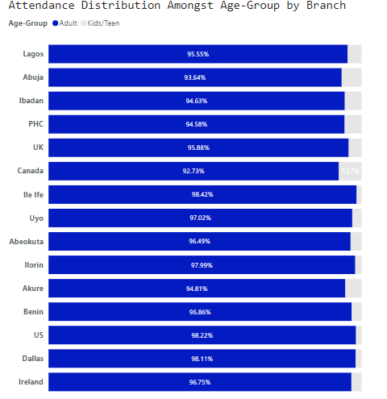

The distribution margin between adults and kids/teenagers is very high with a varying ratio of 95%:5%. The adult age group shows more attendance, but knowing the age-range of these adults can help determine better how to engage them.

1. **Total Attendance Analysis**:
   1. Can you provide a breakdown of total attendance numbers for each branch?

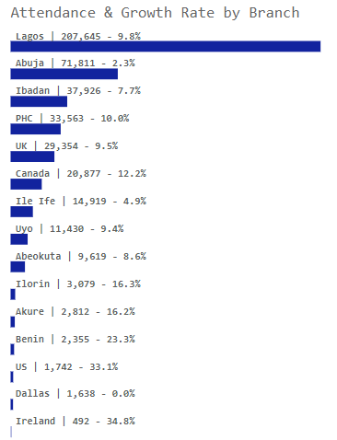

From the chart, we can see that though Lagos and Abuja had the most attendees, their growth rate wasn’t so much compared to branches like Benin, Akure, etc.

* 1. How does attendance vary between weekdays and weekends across branches?

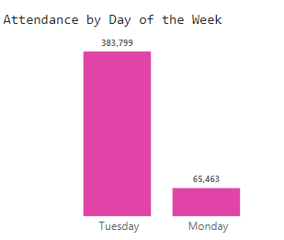

* 1. Are there any outliers or anomalies in attendance data that require further investigation?

There is bias in the data for the days of church programs, therefore we can’t determine the attendance distribution between weekdays and weekends.

1. **Branch Comparison**:
   1. How do attendance numbers compare between branches located in Nigeria and those in other countries?

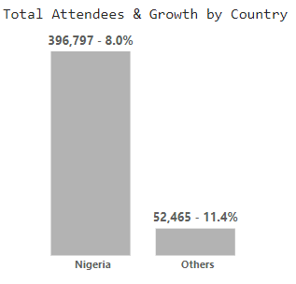

b. Are there any branches that consistently perform better than others in terms of attendance? What factors might contribute to their success?

Generally, though Nigerian branches had more attendees, The performance of branches in other countries was higher.